A COMPREHENSIVE ANALYSIS OF FINANCIAL PERFORMANCE: INSIGHTS FROM A LEADING BANKS

# INTRODUCTION

# 1.1 Overview

Financial performance analysis is a multifaceted approach to evaluating a company’s financial performance. It is the process of examining a business enterprise’s financial records, statements, tools, and process.

# 1.2 Purpose

These financial institutions accept deposits and offers checking and savings account services; make business, personal, and mortgage loans; and provides basic financial products like certificates of deposit (CDs). They may also act as payment agents via credit cards, wire transfers, and currency exchange.

# PROBLEM DEFINITION & DESIGN THINKING

# 2.1 Empathy Map

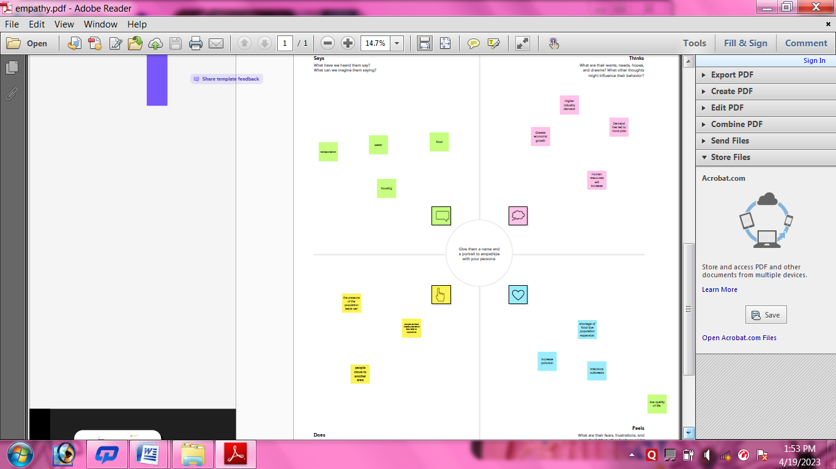

# 2.2 Ideation & Brainstorming

# 

# 3 RESULT

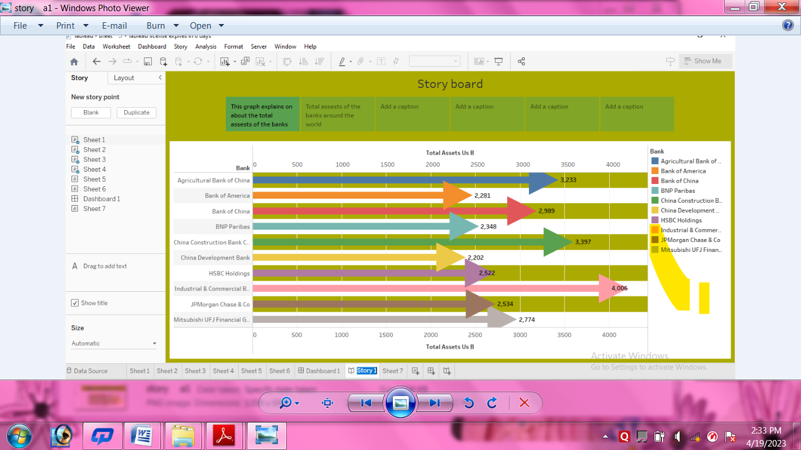

4 ADVANTAGES & DISADVANTAGES

# ADVANTAGE:

1. Bank account offer convenience. For examples,if you have a checking account, you can easily pay by check or through online bill pay.
2. Bank accounts are safe. Your money will be producted from theft and fires.
3. It’s an easy way to save money.
4. Bank account are cheaper.

# DISADVANTAGE:

1. No Actual Branches.
2. Concerns about identity Theft and Security.
3. Deposits Restrictions.
4. Faster is Not Always More Convenient.

# APPLICATIONS

A banking app has to support transaction between user’s own credit cards as well as between the user and a different account. To improve the convenience of a transaction, the program needs to give a mechanism for creating regular payments.

# CONCLUSION

Although Indian banking is on good condition because of its good regulation system but still there are some areas where Indian banking faces problems these five challenges which I discuss is given by our RBI governor in a summit which occurred in feb. of this year. These are some challengs for Indian banking system for making our banking system more stable.

# FUTURE SCOPE

Technological advancements, changes in regulatory environment, and evolving customer needs.

# APPENDIX

1. Github
2. Mural
3. MySQL
4. HTML
5. Tableau
6. HTML